Name: Truong Dang Truc Lam ID: B2111933 Class: CT205H - M04

Comparative Study

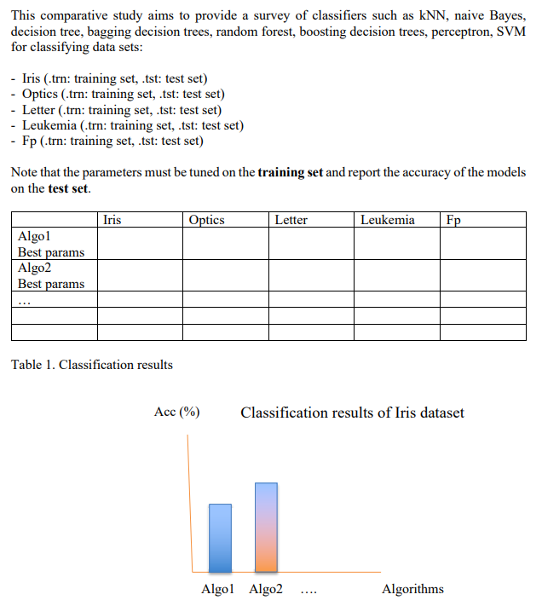

This is the Comparision Table:

|  |  |  |  |  |  |
| --- | --- | --- | --- | --- | --- |
| Accuracy | Iris | Optics | Letter | Leukemia | Fp |
| kNN | 94,00% | 98,00% | 95,27% | 88,24% | 90,62% |
| Naïve Bayes | 92,00% | 78,63% | 63,16% | 91,18% | 75,00% |
| Decision Tree | 92,00% | 85,31% | 85,64% | 91,18% | 78,12% |
| Boosting Decision Trees (AdaBoost) | 94,00% | 96,99% | 94,97% | 91,18% | 96,25% |
| Bagging Decision Trees | 92,00% | 93,27% | 93,70% | 94,12% | 88,75% |
| Random Forest | 92,00% | 96,49% | 95,69% | 82,35% | 96,25% |
| Perceptron | 92,00% | 90,21% | 53,06% | 82,35% | 100,00% |
| SVM | 94,00% | 97,66% | 93,92% | 97,06% | 98,12% |

Comparision Table

Classification results of Iris datasets

Classification results of Optics dataset

Classification results of Letter dataset

Classification results of Leukemia dataset

Classification results of Fp dataset